# ISSUE TICKET GENERATING SYSTEM

## Have made the following Issue Ticket Generating System.

## It uses npm mail gun as a module to send email. It works as follows--->

## User comes fill credentials and Details of issue.

## With that he/she announces for which person is this issue generated for and for which dept.

## After that he logs the issue on the basis of it's priority level --> Critical(within 2 hrs) High(within 5 hrs) or Low(within 24 hrs).

## He is looged into ticket Info page to show his/her as well as other ticket details. Also if the ticket is not

## Resolved within the described time a mail is sent to the handler.

## Just to alarm the handler user can even send the immediate mails.

## Also the Handler can come and reject or resolve the ticket.

# Technologies :- Angular JS Node JS Underscore JS

# DATA Format : JSON

# Built On : Express JS MODULES :: BODY PARSER PATH

# API’s : PING CALL API - GET API - POST API - PUT API – MailGUN API (application.js)

# Controller JS : Main Controller For Main Page & Ticketinfo Controller For TicketInfo Page.

# Module Front-end : ng-route

# Module Back-end : UnderScore , mailgun-js

# PROJECT STRUCTURE ::

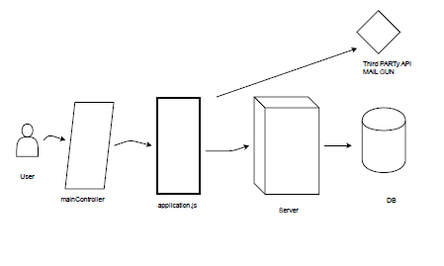

### The following is the ticket Raising System Home Page.

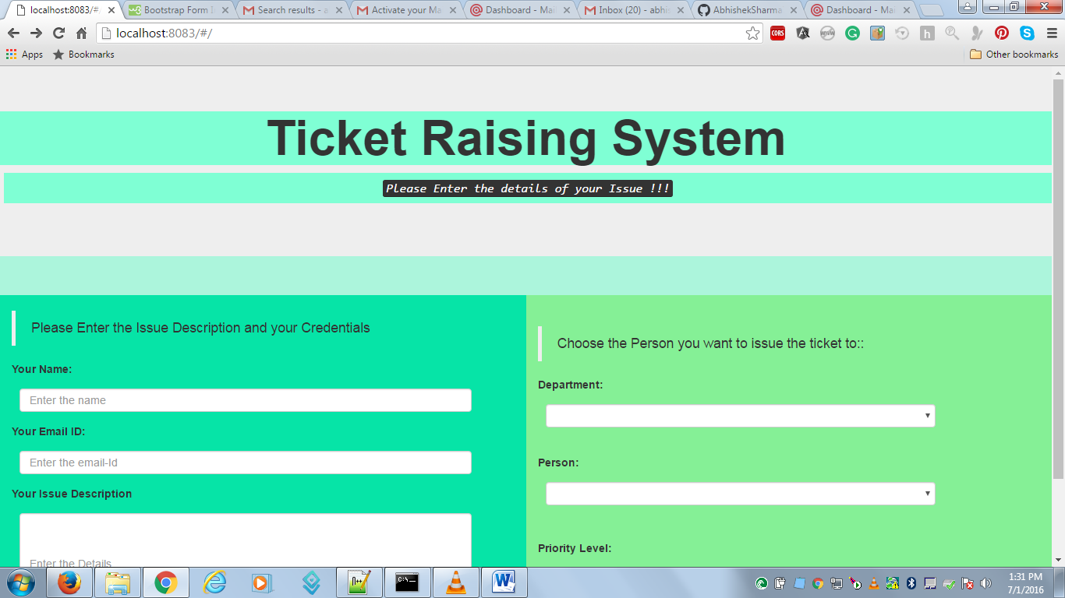

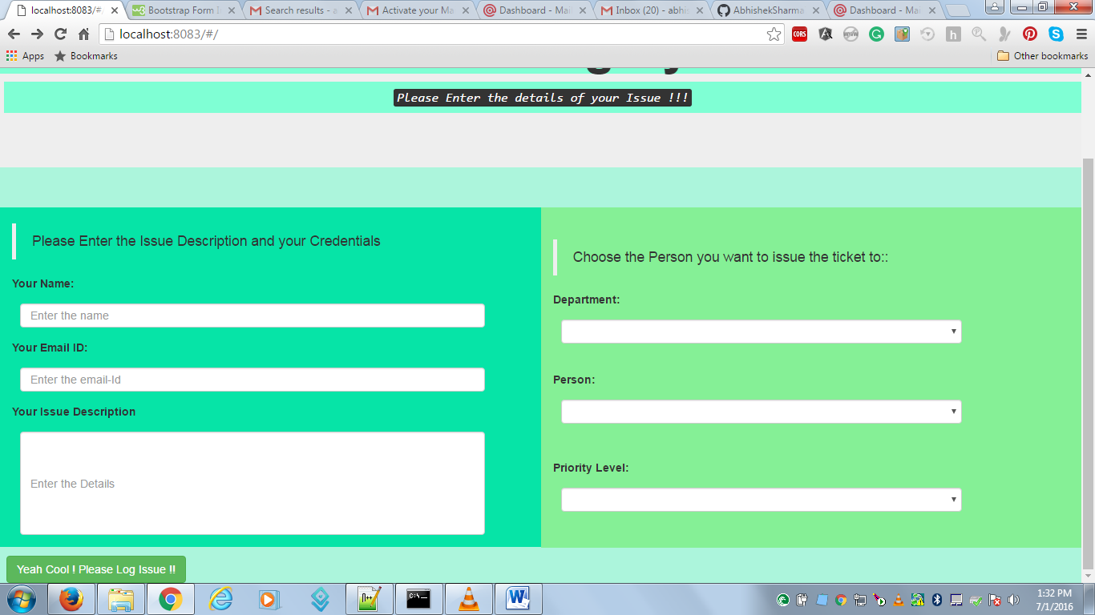

Fill Your Details :-

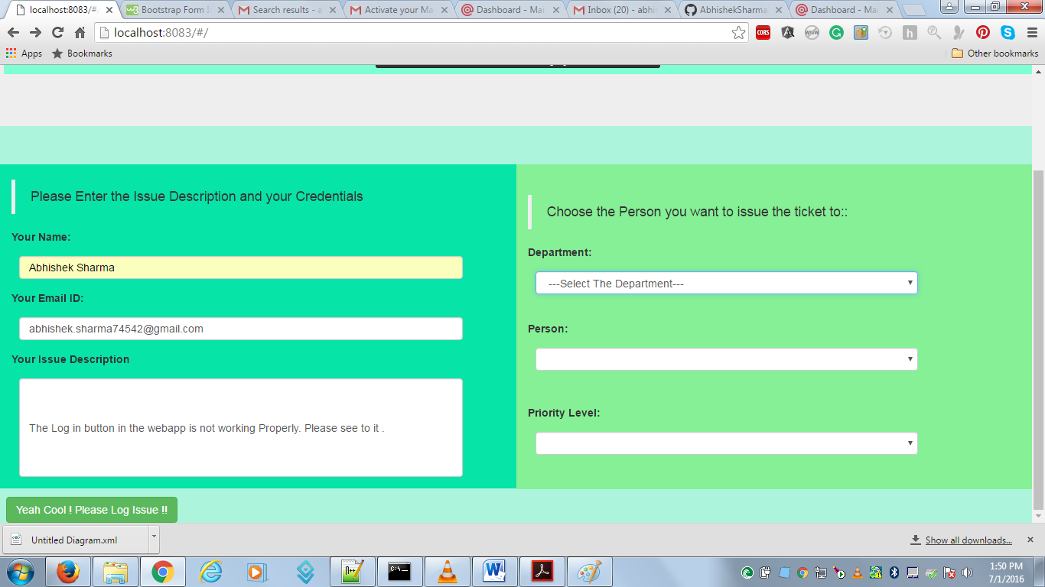

You can choose the Department.

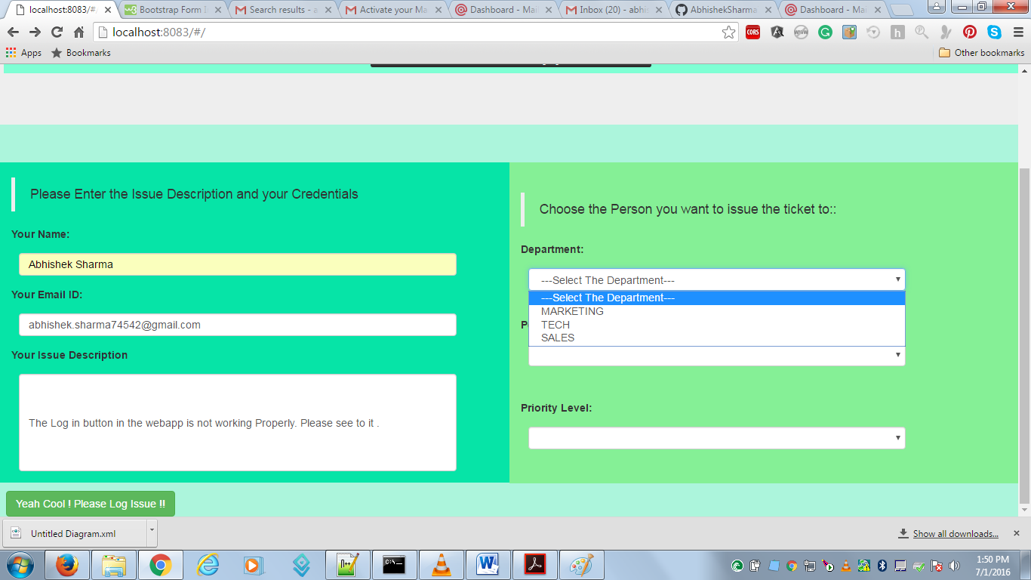

Accordingly the employees will be shown with their info.

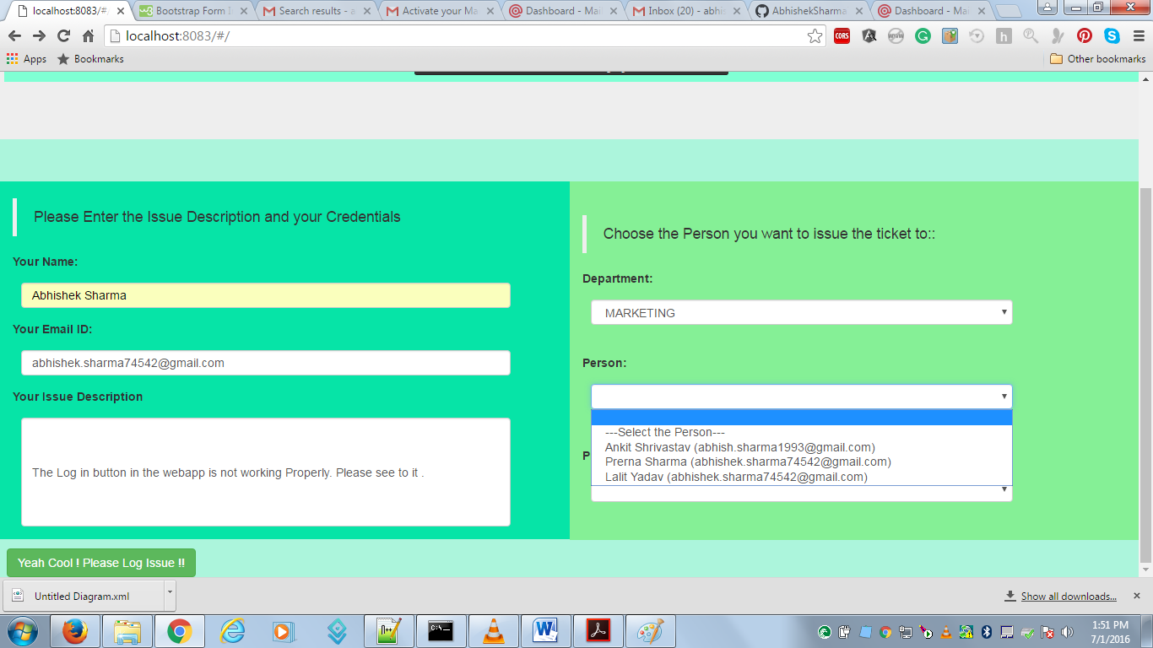

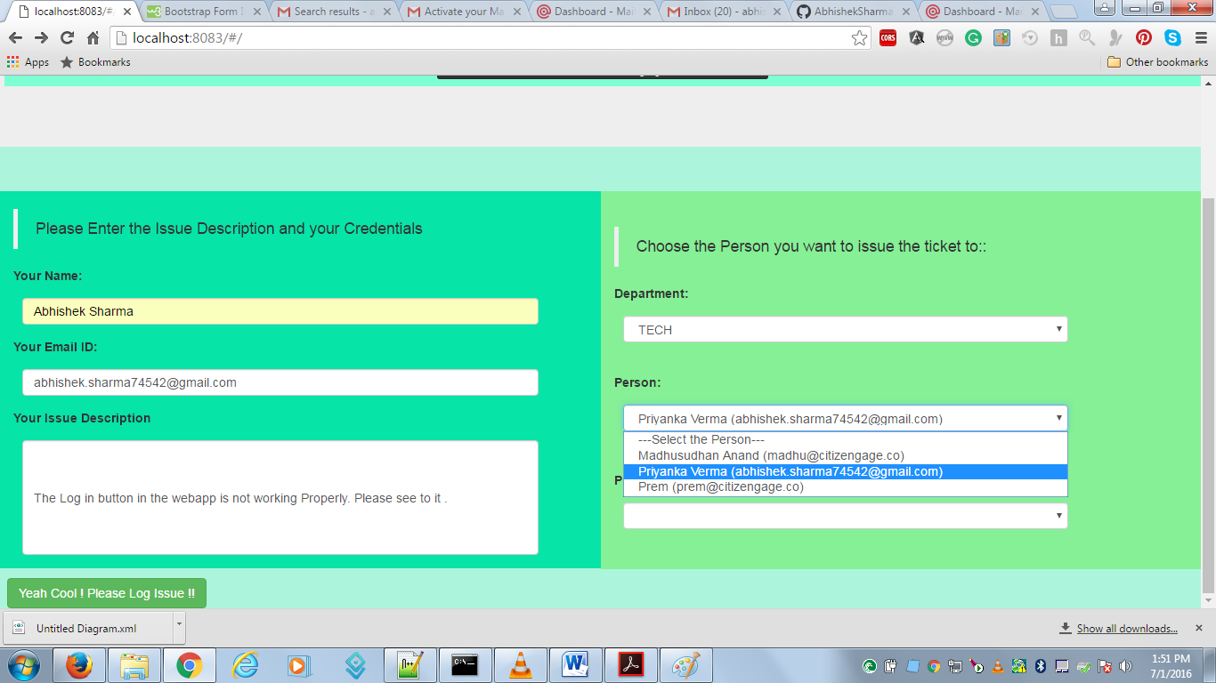

You can Also set the Priority Level

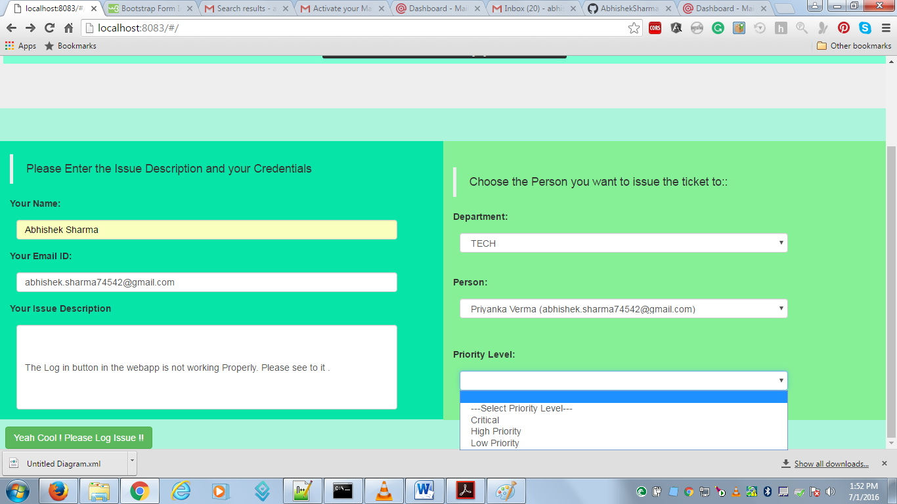

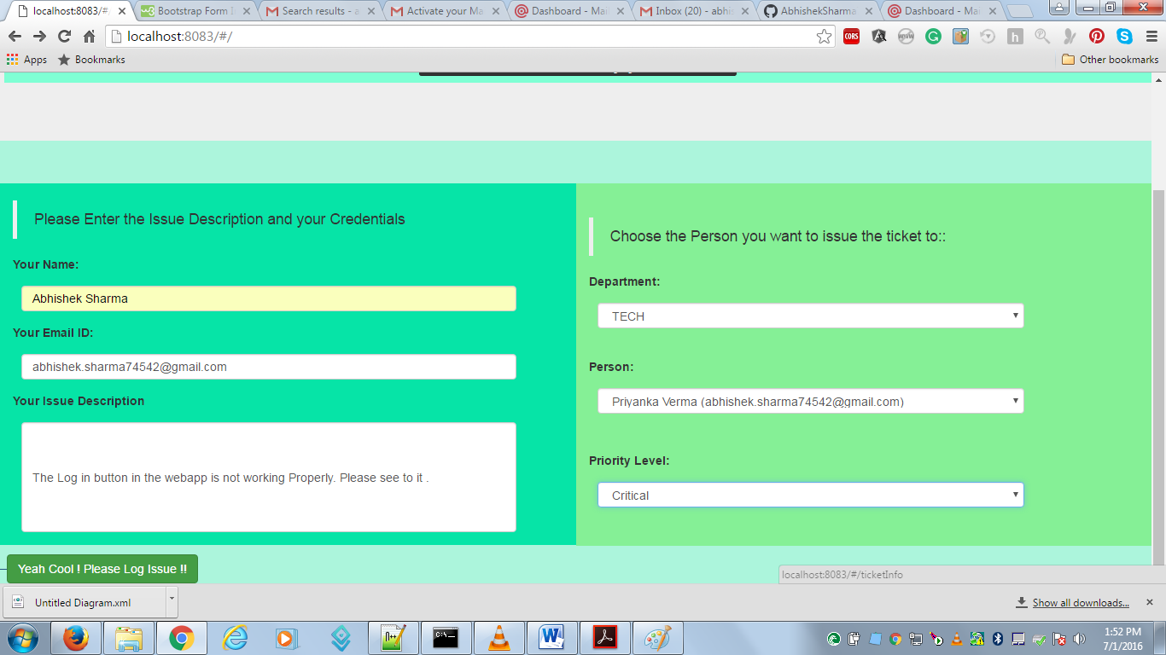

Cool We can Log Issue.



Your Issue will be listed in Current Issue List.

All this is being maintained in a pseudo DB.

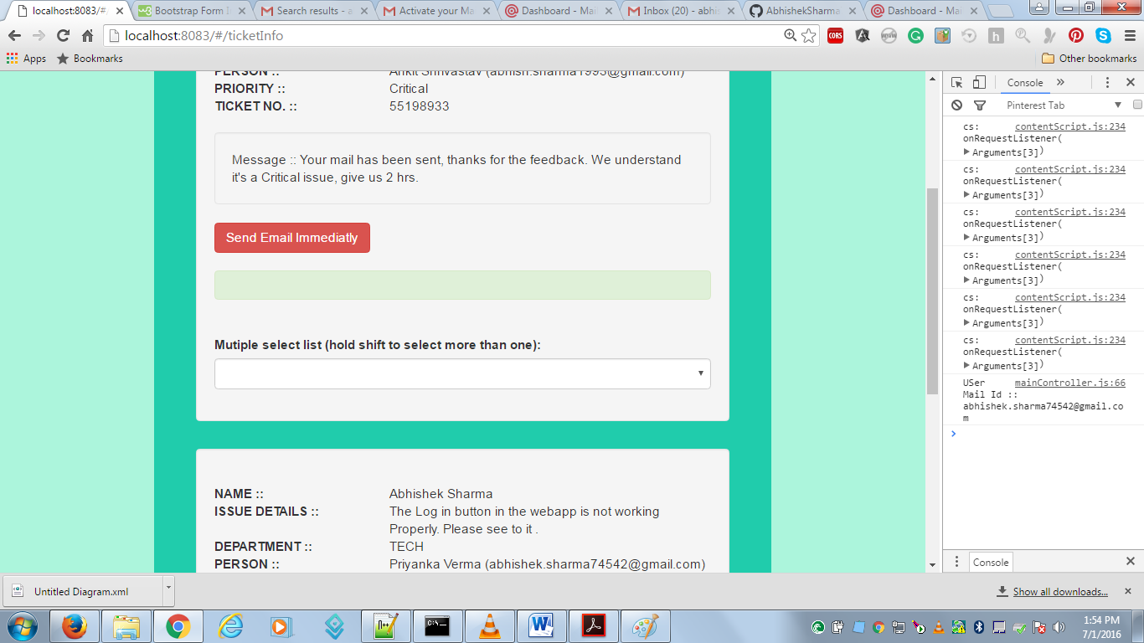

Your Issue will be seen on the screen with all the other details.

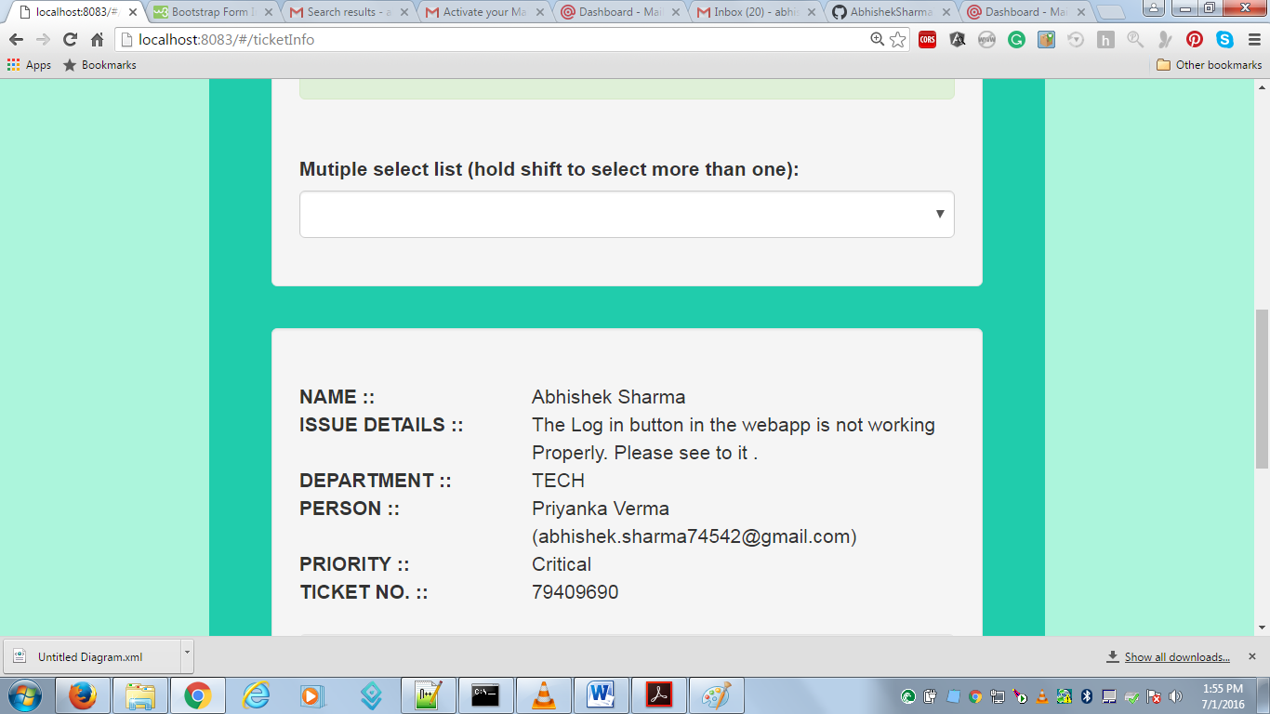

A Message is displayed to show how much time we need to resolve the issue.

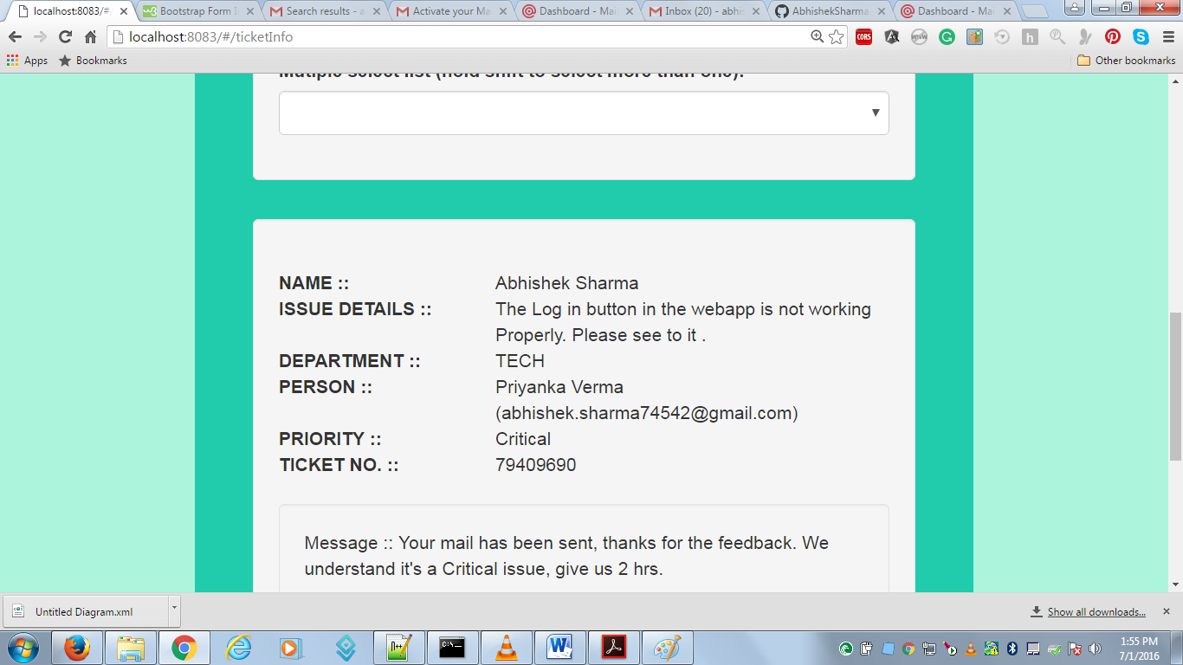

If you are in urgent need you can send a ping mail Immediately.

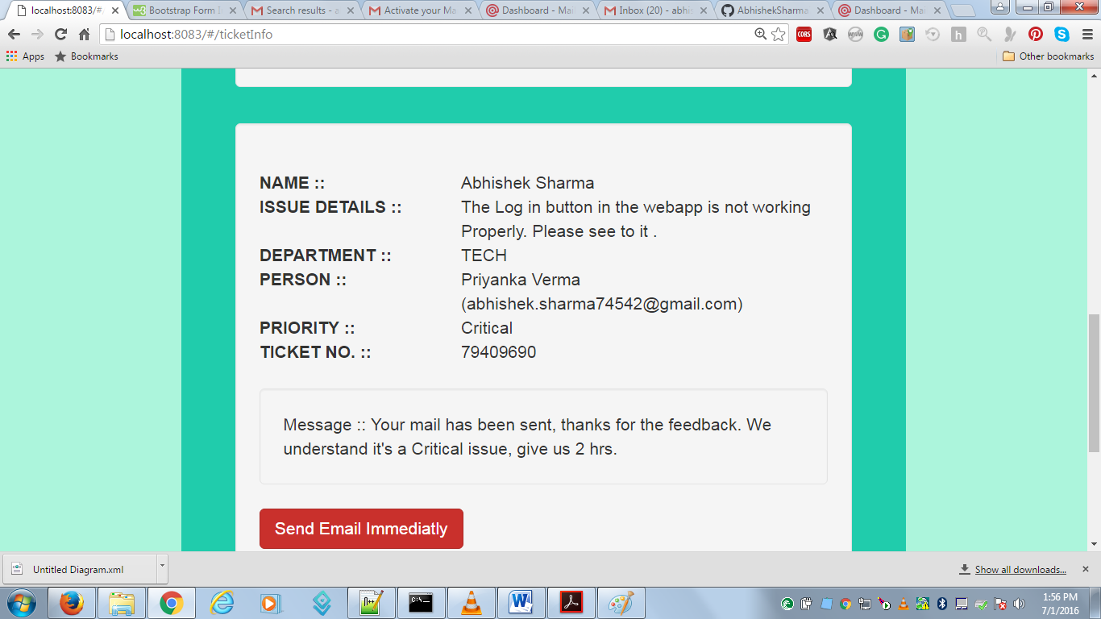

Immediately a message will generate that your issue ping has been sent.

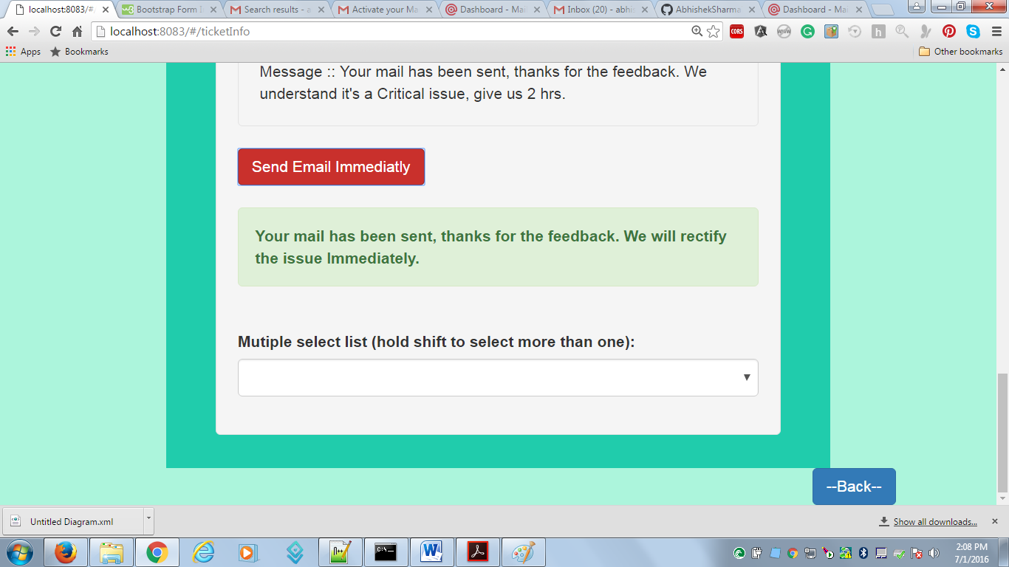

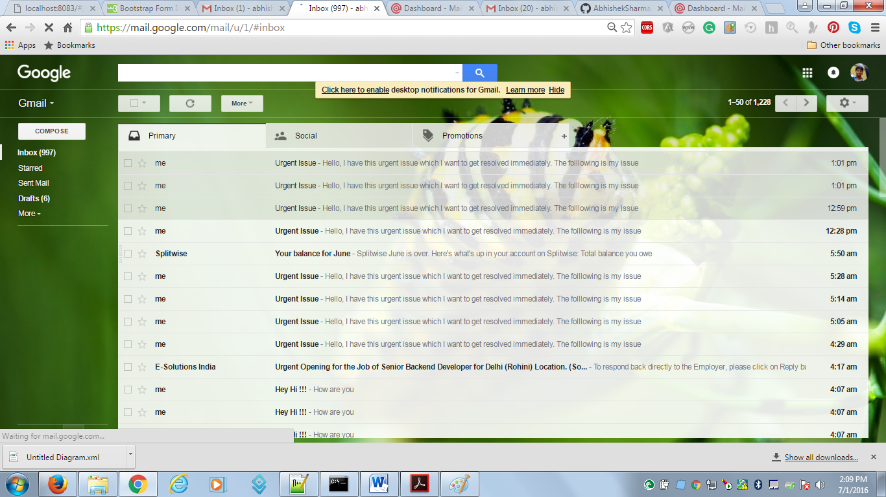

Issue will be mailed to the holder ID

Note : Before sending your id should be verified by mail gun.

Also If your Issue has been resolved you can close the issue by changing status to Resolved.

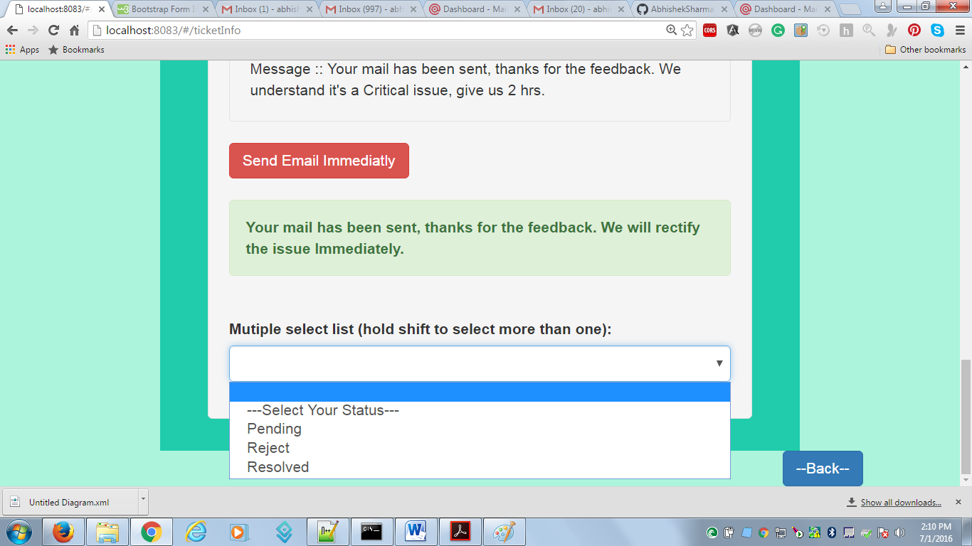.

And then your Issue will be Deleted.

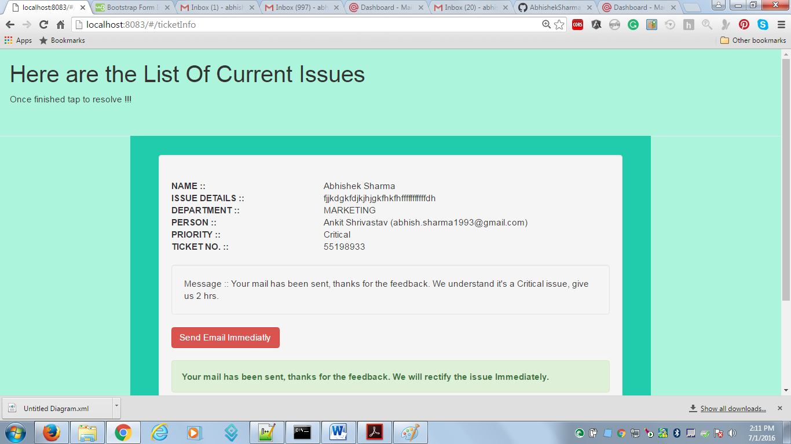

Have some more Issue. ? You can Create a New Issue Again.

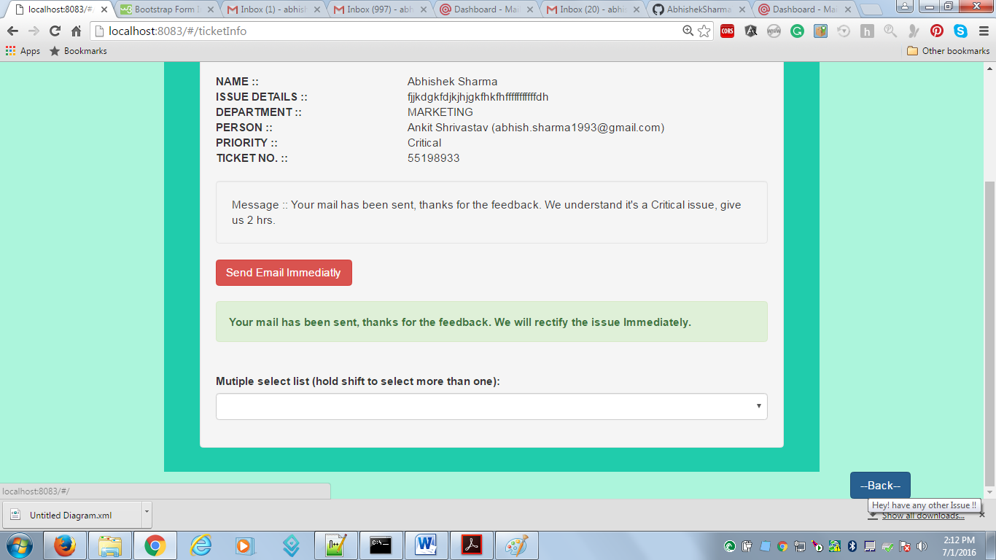

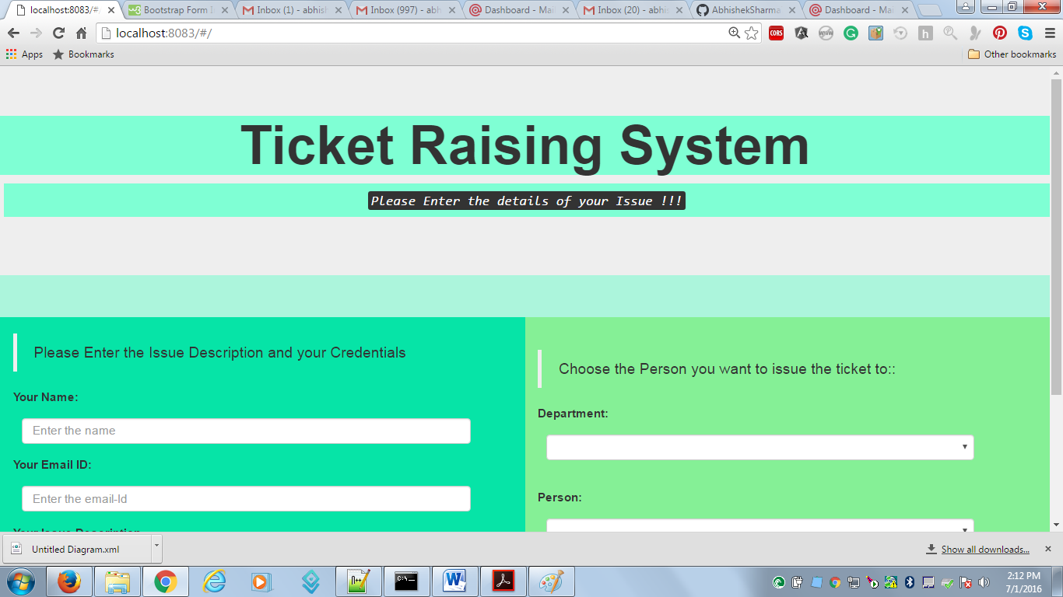

Hope you liked my Task Regards,

Abhishek